Jeffrey Razon

Argenis Jimenez

CPE 403-1001

NSHE 2000718323

CC1350 Lab 4

Github root directory: https://github.com/JeffinVegas/403_AdvEmbSys

Date Due: November 21st, 2018

**Task 1**: Set up Project in SCS

a) Code Generator on SCS

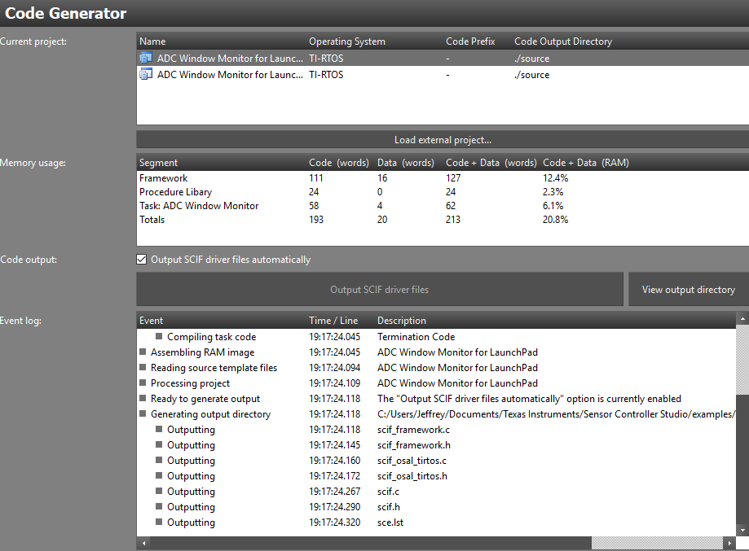

**Task 2**: Download and Debug with CCS

Youtube Link: https://youtu.be/w0MzJ1Vs3tw

**Task 3**: Download and Debug with SCS

Youtube Link: https://youtu.be/9BRhq9sVC8I

a) ADC Graph on SCS

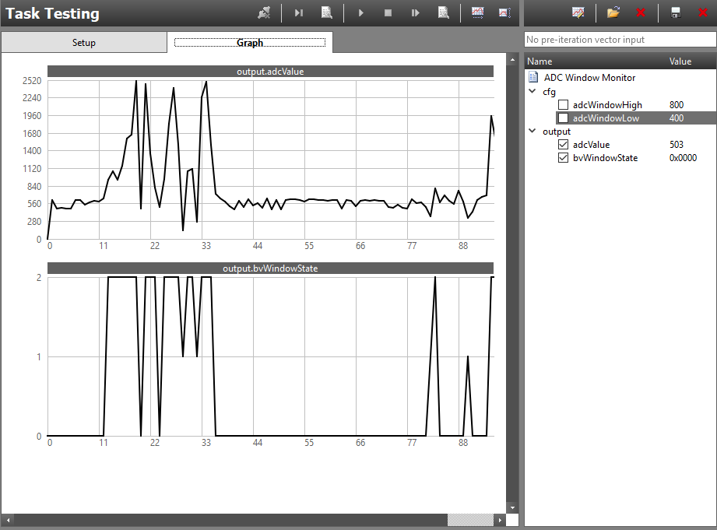

**Task 4**: Understand

- This task is an explanation of the functions within main_tirtos.c